SHOPNEST DASHBORD ANALYSIS

CONTENTS
- Introduction
The ShopNest Visualisation Dashboard is developed as a capstone project, with datasets provided for educational and analytical purposes by SkilloVilla. The datasets provided depicts some real-world e-commerce data and includes customer transactions, product information, and delivery details. The primary agenda of this assignment is to showcase skills related to data modelling, visualization, and business insight extraction using Power BI.

- Objective
The primary objective of this dashboard is to analyze product performance, sales trends, revenue growth while identifying delivery performance and customer satisfaction levels. It aims to assist stakeholders in making informed decisions based on real-time data insights.

- Key Metrics
The dashboard highlights the following key metrics:
- Total Revenue
- Total Orders
- Average Review Score
- Total Revenue State Wise

Visualization-

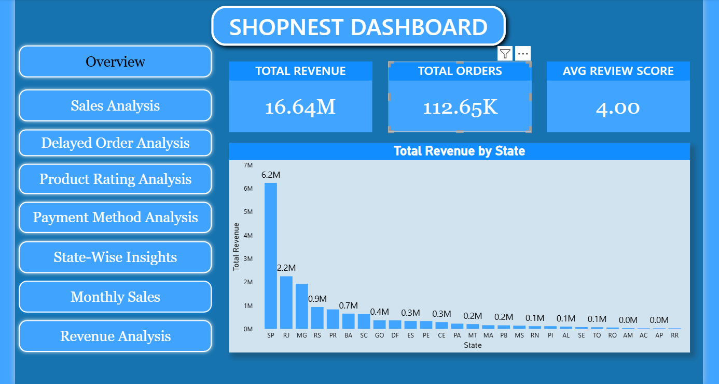

4. Analytical questions and Visualization
4.1. Top categories by total price:
Question statement- Identify and visually represent the top 10 product categories by total sales.
Visualization-
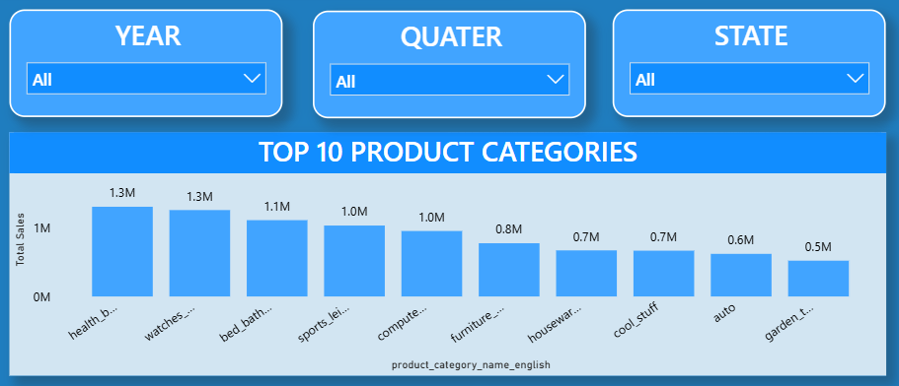

Explanation: This analysis highlights the top 10 performing product categories by total sales. It helps identify which categories of product have driven higher revenue and align marketing efforts accordingly.

4.2. Delayed Order Analysis
Question statement- Determine the number of delayed orders in each category
Visualization-
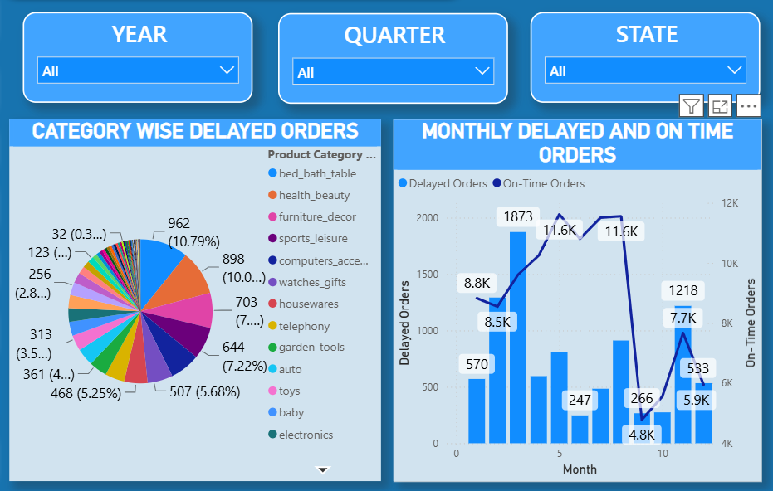

Explanation: This particular analysis showcases the product categories with highest number of delayed deliveries, which enable targeted interventions for better delivery performance

4.3. Monthly Comparison of Delayed and On-Time Orders:
Question statement- Compare the number of delayed orders and to the on-time orders for each month.
Visualization-
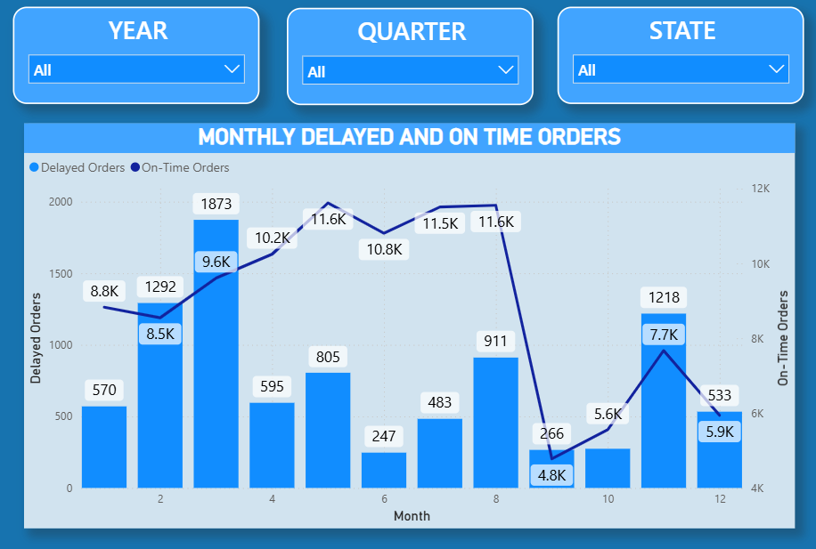
Explanation: This particular analysis tracks the delivery performance overtime, highlighting trends of on-time and delayed orders and helping address the changes over time.

4.4. Payment Method Analysis:
Question statement- Analyze the most frequently used payment methods by customers
Visualization-
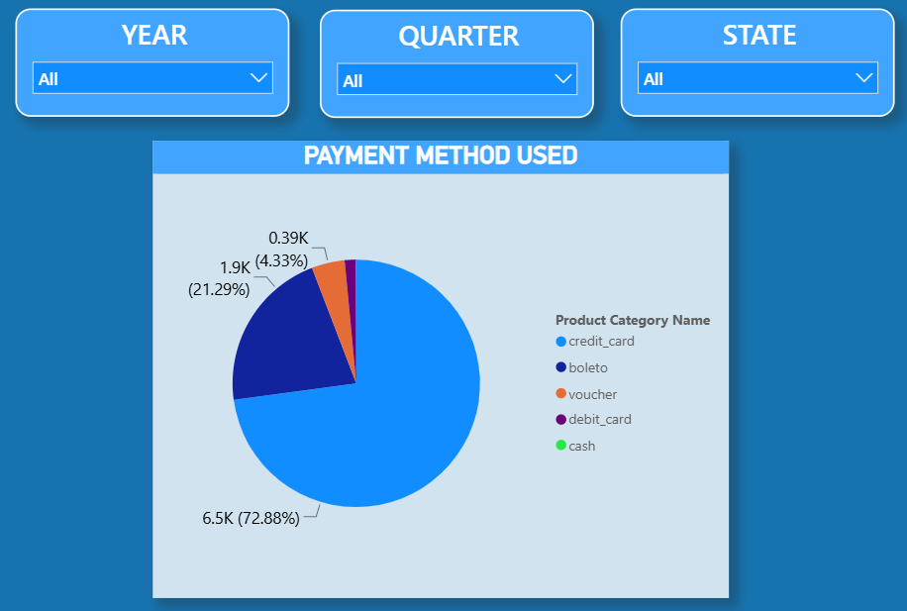
Explanation: This helps in understanding the most popular payment methods used by customers over time which helps in enhancing customers payment experiences and identify preferred modes.

4.5. Product Rating Analysis:
Question statement- Determine the top 10 highest-rated products and bottom 10 lowest-rated products.
Visualization-
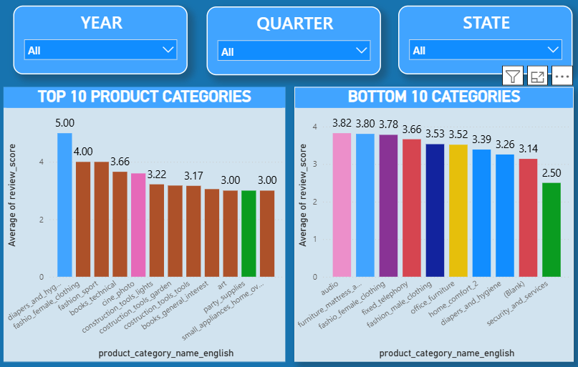
Explanation: This analysis helps identifying well-performing products and addresses issues with badly rated products to enhance customer satisfaction

4.6. Sate-Wise Sales Analysis:
Question Statement: Identify and visually represent states with high and low sales
Visualization-
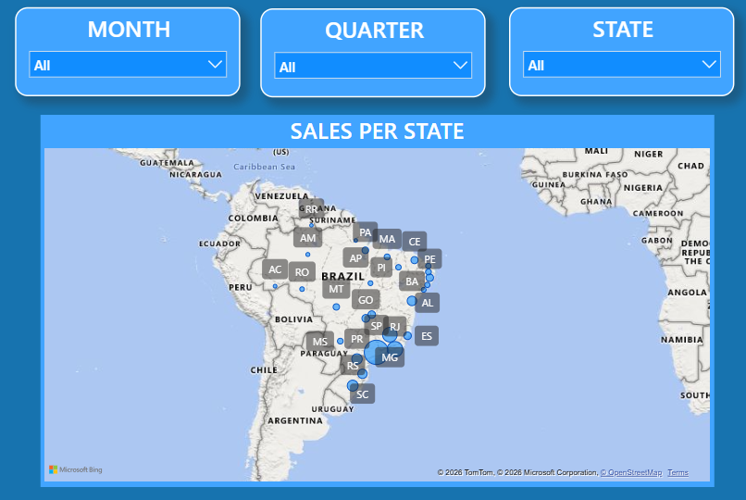

Explanation: This visualization provides a regional sales performance state-wise, allowing for targeted marketing and resource allocation.

4.7. Seasonal Sales Patterns:
Question Statement: Investigate and visualize seasonal patter (Quarterly) or trends in sales data over the course of year.
Visualization-
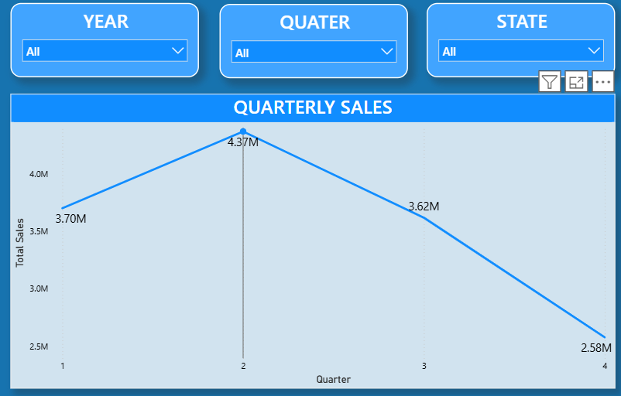
Explanation: This visualisation depicts quarterly sales trends, helping businesses prepare for peak season.

4.8. Revenue Analysis:
Question Statement: Determine Total Revenue generated by ShopNest Store and analyze how it changes over time.
Visualization-

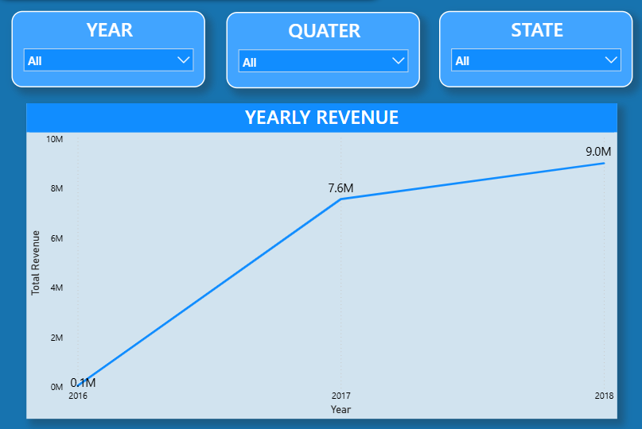
Explanation: This visualization tracks Revenue trends over years and highlighting all the significant growth and decline patterns.

5. Conclusion
The ShopNest Dashboard Analytics provides crucial insights into various aspects of the e-commerce business from various regions in Portugal. Based of the analysis, few recommendations can be made:
- Focus marketing efforts on top-performing product categories.
- Improve delivery processes for product categories with highest delays.
- Address issues with poorly rated products for customer satisfaction.
- Optimise payments methods to cater customer preferences.
- Look over regional and seasonal trends to maximise sales.

